30.10.2013

**Submission Report**

**Assignment 1 for Software Engineering Foundation F21SF**

Student name: Marcin Paweł Kopacz

Person ID: H00176255

Course: Information Technology – Software Systems

1. Introduction

Competition used in program is soapbox race where different teams create vehicles and try to impress judges and audience. As reference I used this:

<http://soapbox.redbull.co.uk/teams>

<http://www.youtube.com/watch?v=9Hpgr9bgpuE>

1. Copetitors atribiutes:

-Id- Unique number 0-100 for each competitor

-Name- Names of teams consist with maximum 3 parts

-Marks- Judges marks for each team, 5 marks in range [0-5]

-Audience- Response of audience [0-100] %

-Level of Art- Measured in range 1-6

1. Overall score calculation:

Overall = Averege of Marks*Audience

1. This application meets the specification fully. Selection is made in console by Scanner.

GetFullDetails() and getShortDetails in my program are methods in CompetitorList class. Stage 2 and Stage 3 where a little misleading. I don’t know if localization of these methods would affect my grade.

**Important**. I did coding on Windows Machine and I was using “\r\n” for next line. Please run this program on Windows.

1. Class diagram.

To create class diagram I used program Visual Paradigm with is free for noncommercial use.

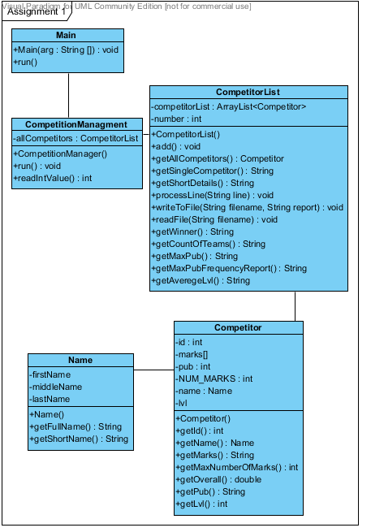

1. Sequence diagram for method getShortDetails()

I use Visual Paradigm with very smart for this kind of task. But still a paint was used to export this.

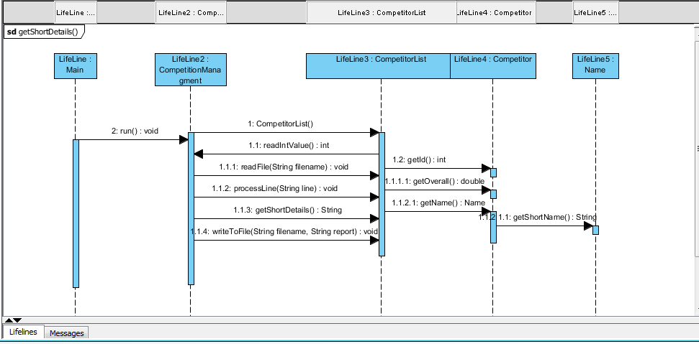

1. Input and output files.
2. List of competitors from DataInput.csv

|  |
| --- |
| 0,Piece of Cake,3,3,4,5,4,70,1 |
| 1,Chariot of Fire,3,4,5,3,2,65,2 |
| 2,Here For Beer,2,3,3,4,4,60,5 |
| 3,The Regulators,4,4,3,4,4,80,5 |
| 4,The Bee Team,3,3,1,4,2,50,6 |
| 5,TheRun Away Bakers,4,3,3,4,1,65,5 |
| 6,The Downtown Destroyer,4,4,4,3,4,90,4 |
| 7,Spit-Phya,5,5,5,4,5,98,5 |
| 8,The Bath Mobile,4,2,4,3,3,100,5 |
| 9,The Coffin Dodgers,3,3,4,3,2,30,3 |
| 10,Fly High,3,4,2,1,1,60,5 |

1. The report created by program. Word did some formatting on it.

Full raport of competitors.

Id Team name Marks from Judges Audience Responce % Overall Level

0 Piece of Cake 3 3 4 5 4 70 2,2 1

1 Chariot of Fire 3 4 5 3 2 65 1,8 2

2 Here For Beer 2 3 3 4 4 60 1,6 5

3 The Regulators 4 4 3 4 4 80 2,5 5

4 The Bee Team 3 3 1 4 2 50 1,1 6

5 TheRun Away Bakers 4 3 3 4 1 65 1,6 5

6 The Downtown Destroyer 4 4 4 3 4 90 2,9 4

7 Spit-Phya 5 5 5 4 5 98 3,9 5

8 The Bath Mobile 4 2 4 3 3 100 2,7 5

9 The Coffin Dodgers 3 3 4 3 2 30 0,8 3

10 Fly High 3 4 2 1 1 60 1,1 5

Full details for 6

Team name is The Downtown Destroyer.

Judges gives them following marks: 4 4 4 3 4

Audience responce was: 90%.

This would give them Overall Score: 2,9 Level artism: 4

Short details for 6

Id 6 (TDD) has overall score 2,9

Winner of Soapbox competition is:

Team name is Spit-Phya.

Judges gives them following marks: 5 5 5 4 5

Audience responce was: 98%.

This would give them Overall Score: 3,9 Level of art: 5

Total number of teams in this year competition is :11

Audience have highest respond of: 100

How offen given Level of Art was used

Level of Art 1 : 1

Level of Art 2 : 1

Level of Art 3 : 1

Level of Art 4 : 1

Level of Art 5 : 6

Level of Art 6 : 1

Averege Level of Art is: 4,0

**Other files made by testing will be provided and also they are in project directory.**

1. Testing
2. Table of limitations

|  |  |  |
| --- | --- | --- |
| Id | Problem | Effect |
| 1 | Marks as string | Catch work, but because of wrong index Name class crush |
| 2 | Marks with high numbers 100 and more | Can accept any integer value but it will provide unreasonable results |
| 3 | Very long name | Can be longer name with more parts but method getShortDetails() will be affected and will not produce good results |
| 4 | Audience response as string | Catch work well and skip bad competitor |
| 5 | Level of Art with as char | Catch work but method frequency report crash program |
| 6 | Very long competition list >100 | Program crush in method frequency report |
| 7 | Id competitor s> 1000 | Program work normaly |

1. Table of tests. Id corresponds to file names in test directory.

|  |  |  |
| --- | --- | --- |
| Id | Test | Tested |
| 1 | Marks are integers | Marks=[ 3,3,b,5,4,], |
| 2 | Marks are between [0-5] | Marks=[ 3,3,100,1000,4,], |
| 3 | Name have maximum 3 “parts” | 6,The Downtown Destroyer with big Stick |
| 4 | Audience response should be int | 10,Fly High,3,4,2,1,1,6ala,5 |
| 5 | Level of Art need to be int | 0,Piece of Cake,3,3,4,5,4,70,b |
| 6 | Competition list should be limited | More than 140 competitors by copy |
| 7 | Id of competitors should be 0-100 | |  | | --- | | 100,Piece of Cake,3,3,4,5,4,70,1 | | 2222,Chariot of Fire,3,4,5,3,2,65,2 | |

1. Javadoc style comments for CompetitionList

It is attached form this page from separate document. Also in my project you can find pdf file with javadoc.